

CSA0506-Database Management Systems

Lab Experiments

Ashmi P S
192571004

EXP: 16: High Level Programming Extensions – Procedures
AIM:To create and execute a Stored Procedure in MySQL.
ALGORITHM :
· Create a database.
· Select the database.
· Create a table.
· Insert records.
· Create a stored procedure.
· Execute the procedure using CALL.
· Display the output

QUERY:
DROP DATABASE IF EXISTS EmployeeDB;
CREATE DATABASE EmployeeDB;
USE EmployeeDB;
CREATE TABLE Employee(
EmpID INT PRIMARY KEY,
EmpName VARCHAR(30),
Department VARCHAR(20),
Salary INT
);
INSERT INTO Employee VALUES
(101,'Rahul','CSE',30000),
(102,'Anitha','ECE',35000),
(103,'Kiran','IT',40000),
(104,'Sneha','CSE',38000);
DELIMITER $$
CREATE PROCEDURE ShowEmployee()
BEGIN
SELECT * FROM Employee;
END $$

DELIMITER ;
CALL ShowEmployee();
OUTPUT:
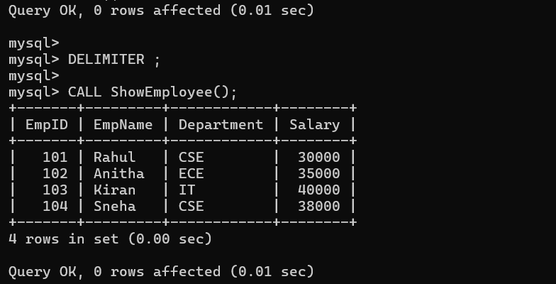

EXP 17: High Level Programming Extensions – Function
AIM:
To create and execute a Stored Function in MySQL.
ALGORITHM:
- Create a database.
- Select the database.
- Create a stored function.
- Execute the function using the SELECT statement.
- Display the output.
QUERY:
DROP DATABASE IF EXISTS FunctionDB;
CREATE DATABASE FunctionDB;
USE FunctionDB;
DELIMITER $$
CREATE FUNCTION Square(num INT)
RETURNS INT
DETERMINISTIC
BEGIN
RETURN num*num;
END $$
DELIMITER ;

SELECT Square(5) AS Result;
SELECT Square(10) AS Resul;
OUTPUT:
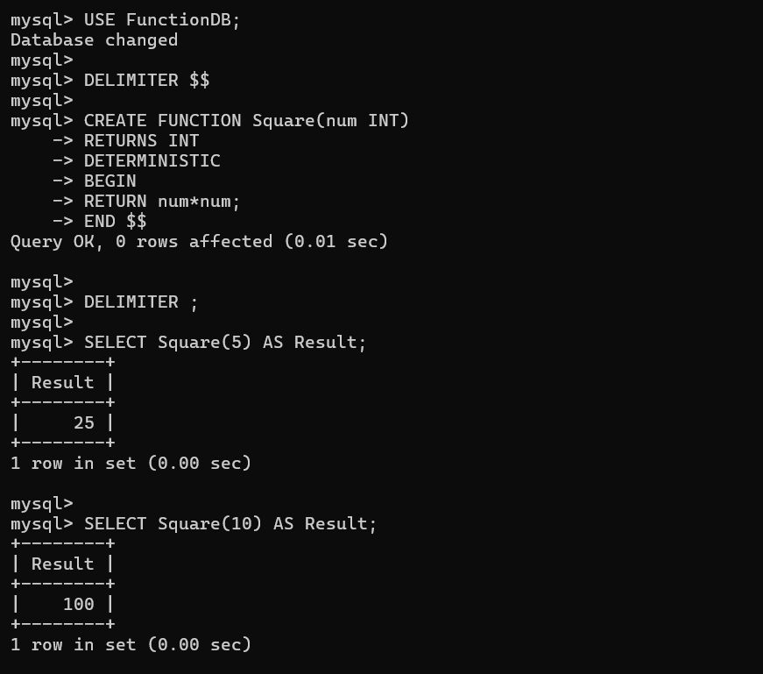

EXP 18: High Level Programming Extensions – Cursors
AIM:
To create and execute a Cursor in MySQL.
ALGORITHM:
- Create a database.
- Select the database.
- Create a table.
- Insert records.
- Create a procedure using a cursor.
- Open the cursor.
- Fetch records from the cursor.
- Close the cursor.
- Execute the procedure.
QUERY:
DROP DATABASE IF EXISTS CursorDB;
CREATE DATABASE CursorDB;
USE CursorDB;
CREATE TABLE Student(
RollNo INT PRIMARY KEY,
Name VARCHAR(30),
Marks INT
);
INSERT INTO Student VALUES
(101,'Rahul',85),
(102,'Anitha',90),
(103,'Kiran',78);
DELIMITER $$
CREATE PROCEDURE CursorDemo()
BEGIN
DECLARE done INT DEFAULT 0;
DECLARE sname VARCHAR(30);
DECLARE cur CURSOR FOR
SELECT Name FROM Student;
DECLARE CONTINUE HANDLER FOR NOT FOUND
SET done=1;
OPEN cur;
read_loop: LOOP
FETCH cur INTO sname;
IF done=1 THEN
LEAVE read_loop;
END IF;
SELECT sname AS Student_Name;
END LOOP;
CLOSE cur;
END $$
DELIMITER ;
CALL CursorDemo();
OUTPUT:
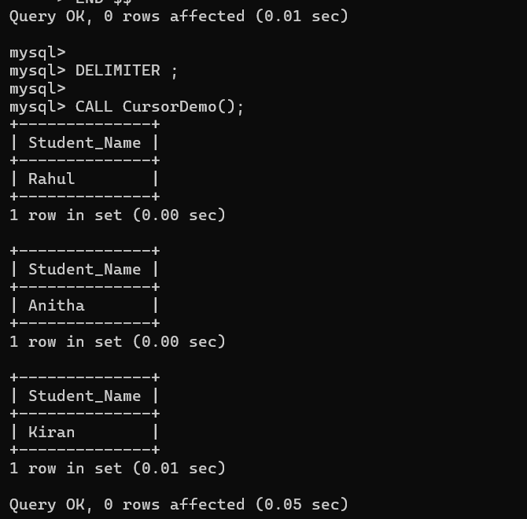

EXP 19:High Level Programming Extensions – Triggers
AIM:
To create and execute a Trigger in MySQL.
ALGORITHM:
· Create a database.
· Select the database.
· Create a table.
· Create a trigger.
· Insert records into the table.
· Display the records.
QUERY:
DROP DATABASE IF EXISTS TriggerDB;
CREATE DATABASE TriggerDB;
USE TriggerDB;
CREATE TABLE Employee(
EmpID INT PRIMARY KEY,
EmpName VARCHAR(30),
Salary INT
);
DELIMITER $$
CREATE TRIGGER CheckSalary
BEFORE INSERT
ON Employee
FOR EACH ROW
BEGIN
IF NEW.Salary<10000 THEN
SET NEW.Salary=10000;
END IF;
END $$
DELIMITER ;
INSERT INTO Employee VALUES
(101,'Rahul',8000),
(102,'Anitha',25000),
(103,'Kiran',9000);
SELECT * FROM Employee;
OUTPUT:
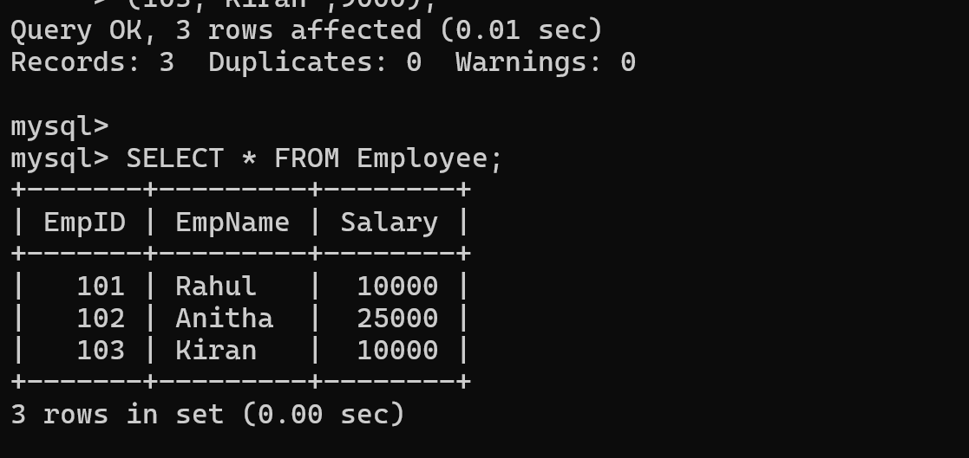
EXP 20: MYSQL String Functions- REPLACE, REPEAT, REVERSE, RIGHT, LEFT,RPAD, LPAD
AIM:
To perform MySQL String Functions: **REPLACE(), REPEAT(), REVERSE(), RIGHT(), LEFT(), RPAD(), and LPAD().
ALGORITHM:
· Create a database.
· Select the database.
· Create a table.
· Insert records.
· Apply different string functions.
· Display the results
QUERY:
DROP DATABASE IF EXISTS StringDB;
CREATE DATABASE StringDB;
USE StringDB;
CREATE TABLE Student(
RollNo INT PRIMARY KEY,
Name VARCHAR(30)
);
INSERT INTO Student VALUES
(101,'Rahul'),
(102,'Anitha'),
(103,'Kiran');
SELECT * FROM Student;
SELECT Name,REPLACE(Name,'a','@') AS Replace_Name
FROM Student;
SELECT Name,REPEAT(Name,2) AS Repeat_Name
FROM Student;
SELECT Name,REVERSE(Name) AS Reverse_Name
FROM Student;
SELECT Name,RIGHT(Name,3) AS Right_Name
FROM Student;
SELECT Name,LEFT(Name,3) AS Left_Name
FROM Student;
SELECT Name,RPAD(Name,10,'*') AS RPad_Name
FROM Student;
SELECT Name,LPAD(Name,10,'*') AS LPad_Name
FROM Student;

OUTPUT:
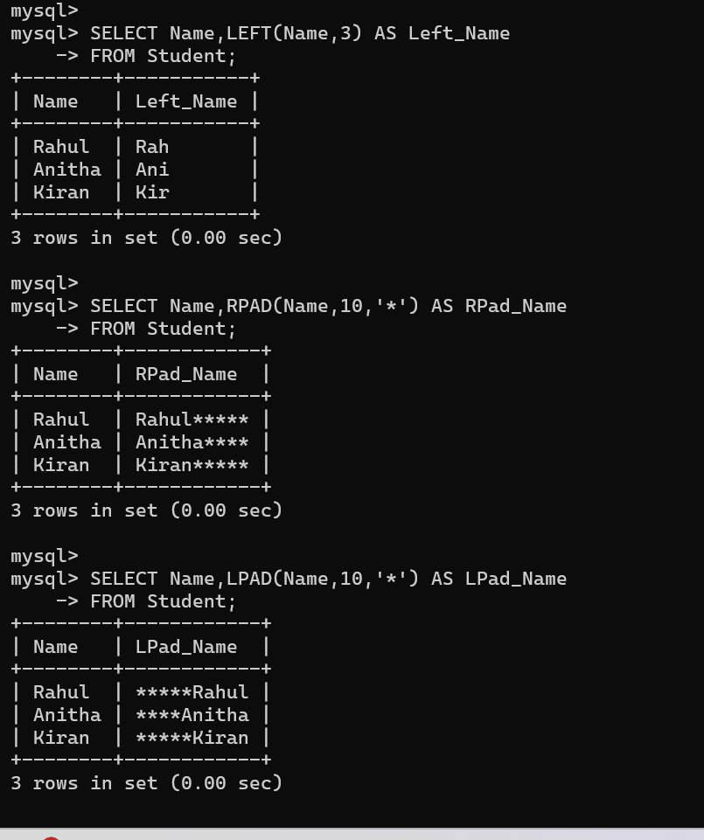

EXP 21: MYSQL String Functions- SPACE, SUBSTR, UPPER,LOWER, TRIM, LENGTH
AIM:
To perform MySQL String Functions: **SPACE(), SUBSTR(), UPPER(), LOWER(), TRIM(), and LENGTH().
ALGRITHM:
· Create a database.
· Select the database.
· Create a table.
· Insert records.
· Apply different string functions.
· Display the results.
QUERY:
DROP DATABASE IF EXISTS StringDB;
CREATE DATABASE StringDB;
USE StringDB;
CREATE TABLE Student(
RollNo INT PRIMARY KEY,
Name VARCHAR(30)
);
INSERT INTO Student VALUES
(101,'Rahul'),
(102,' Anitha '),
(103,'Kiran');
SELECT * FROM Student;
SELECT SPACE(5);
SELECT Name,SUBSTR(Name,2,3) AS Sub_String
FROM Student;
SELECT Name,UPPER(Name) AS Upper_Name
FROM Student;
SELECT Name,LOWER(Name) AS Lower_Name
FROM Student;
SELECT Name,TRIM(Name) AS Trim_Name
FROM Student;
SELECT Name,LENGTH(Name) AS Name_Length
FROM Student;

OUTPUT:
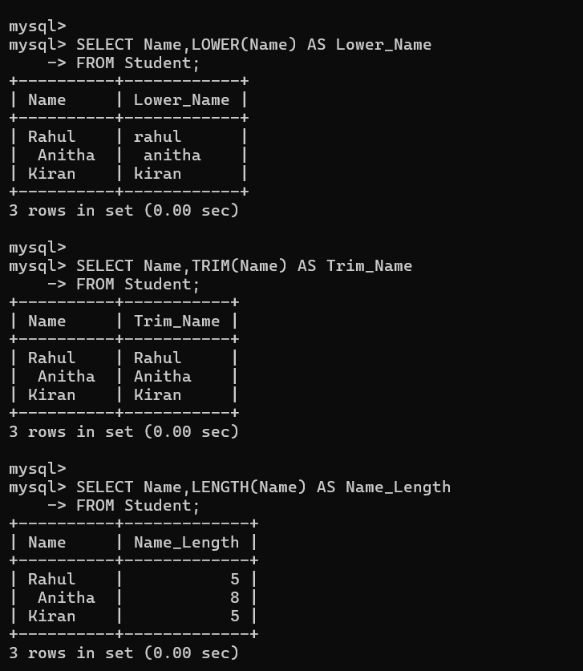

EXP 22:Database Connectivity Using PHP and MYSQL
AIM:
To establish Database Connectivity between PHP and MySQL and retrieve records from a database.
ALGORITHM:
· Create a database.
· Create a table and insert records.
· Create a PHP file.
· Connect PHP to the MySQL database.
· Execute a SELECT query.
· Display the records.
· Close the database connection.
QUERY:
DROP DATABASE IF EXISTS StudentDB;
CREATE DATABASE StudentDB;
USE StudentDB;
CREATE TABLE Student(
RollNo INT PRIMARY KEY,
Name VARCHAR(30),
Department VARCHAR(20)
);
INSERT INTO Student VALUES
(101,'Rahul','CSE'),
(102,'Anitha','ECE'),
(103,'Kiran','IT');
SELECT * FROM Student;

OUTPUT:
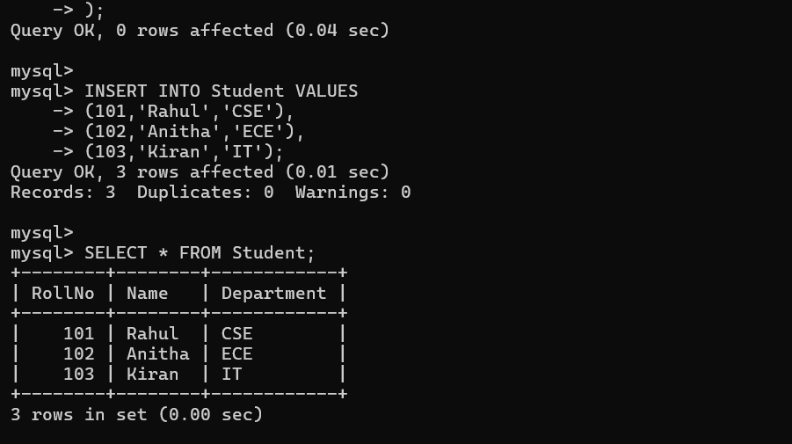

EXP 23: Case Scenario : MySQL Queries Implementation for Train Ticket Reservation System to Receive Tickets through Social Network
AIM:
To implement MySQL queries for a Train Ticket Reservation System to manage passenger and ticket details.
ALGORITHM:
· Create a database.
· Select the database.
· Create a table.
· Insert train reservation records.
· Retrieve all records.
· Retrieve passengers based on conditions.
· Display sorted records.
QUERY:
DROP DATABASE IF EXISTS TrainDB;
CREATE DATABASE TrainDB;
USE TrainDB;
CREATE TABLE Reservation(
TicketID INT PRIMARY KEY,
PassengerName VARCHAR(30),
TrainName VARCHAR(30),
Source VARCHAR(30),
Destination VARCHAR(30),
SeatNo VARCHAR(10),
Status VARCHAR(20)
);
INSERT INTO Reservation VALUES
(101,'Rahul','Vande Bharat','Chennai','Bangalore','S1-12','Booked'),
(102,'Anitha','Shatabdi','Hyderabad','Chennai','B2-25','Booked'),
(103,'Kiran','Duronto','Delhi','Mumbai','A1-10','Waiting'),
(104,'Sneha','Garib Rath','Bangalore','Goa','S2-18','Booked');
SELECT * FROM Reservation;
SELECT * FROM Reservation
WHERE Status='Booked';

SELECT PassengerName,TrainName,SeatNo
FROM Reservation
ORDER BY PassengerName;

OUTPUT:
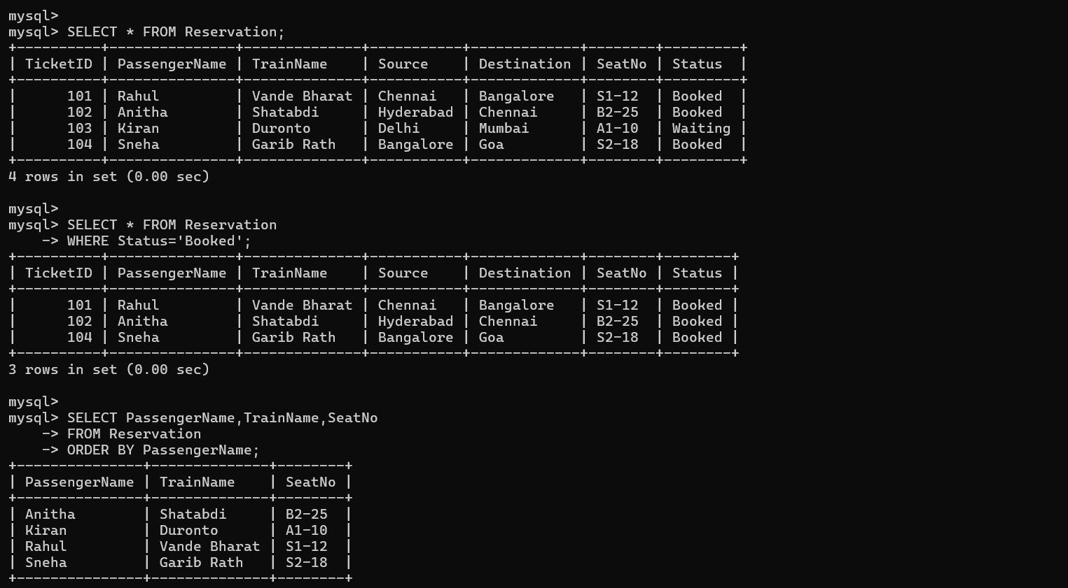

EXP 24:Case Scenario : MySQL Queries Implementation for College Admission Form
AIM:
To implement MySQL queries for a College Admission Form system.
ALGORITHM:
· Create a database.
· Select the database.
· Create a table.
· Insert admission details.
· Display all records.
· Retrieve records using the WHERE clause.
· Sort the records using ORDER BY.
QUERY:
DROP DATABASE IF EXISTS AdmissionDB;
CREATE DATABASE AdmissionDB;
USE AdmissionDB;
CREATE TABLE Admission(
ApplicationNo INT PRIMARY KEY,
StudentName VARCHAR(30),
Course VARCHAR(20),
Marks INT,
City VARCHAR(20),
Status VARCHAR(20)
);
INSERT INTO Admission VALUES
(101,'Rahul','CSE',92,'Chennai','Selected'),
(102,'Anitha','ECE',88,'Hyderabad','Selected'),
(103,'Kiran','IT',75,'Bangalore','Waiting'),
(104,'Sneha','AIML',95,'Mumbai','Selected'),
(105,'Ravi','CSE',70,'Delhi','Waiting');
SELECT * FROM Admission;
SELECT * FROM Admission
WHERE Status='Selected';

SELECT StudentName,Course,Marks
FROM Admission
WHERE Marks>80;
SELECT * FROM Admission
ORDER BY Marks DESC;
OUTPUT:
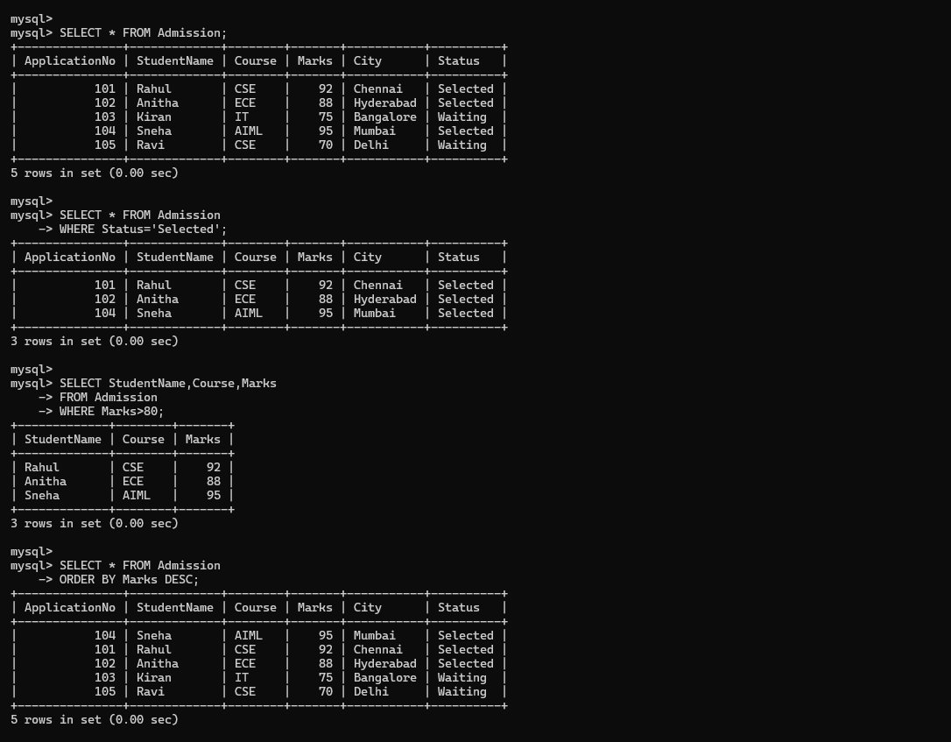

EX 25: Case Scenario : MySQL Queries Implementation for QR Enabled Automatic Bus Ticket Booking System
AIM:
To implement MySQL queries for a QR Enabled Automatic Bus Ticket Booking System.
ALGORITHM:
· Create a database.
· Select the database.
· Create a table.
· Insert bus ticket booking records.
· Display all records.
· Retrieve booked tickets using the WHERE clause.
· Sort the records using ORDER BY.
QUERY:
DROP DATABASE IF EXISTS BusDB;
CREATE DATABASE BusDB;
USE BusDB;
CREATE TABLE BusTicket(
TicketID INT PRIMARY KEY,
PassengerName VARCHAR(30),
BusName VARCHAR(30),
Source VARCHAR(30),
Destination VARCHAR(30),
Fare INT,
QRCode VARCHAR(20),
Status VARCHAR(20)
);
INSERT INTO BusTicket VALUES
(101,'Rahul','APSRTC','Chennai','Vellore',150,'QR101','Booked'),
(102,'Anitha','TNSTC','Hyderabad','Chennai',650,'QR102','Booked'),
(103,'Kiran','KSRTC','Bangalore','Mysore',250,'QR103','Cancelled'),
(104,'Sneha','APSRTC','Vijayawada','Tirupati',400,'QR104','Booked'),
(105,'Ravi','TSRTC','Warangal','Hyderabad',180,'QR105','Booked');

SELECT * FROM BusTicket;
SELECT * FROM BusTicket
WHERE Status='Booked';
SELECT PassengerName,BusName,QRCode
FROM BusTicket;
SELECT * FROM BusTicket
ORDER BY Fare ASC;
OUTPUT:
